**Report for Income Tax Calculator**

As a project work of Course

Python Programming (INT 213)

**---------------------------------------------------------------------------------------------------------**

Name : Md Modassir Alam

Registration Number : 12014759

Program : B-Tech CSE

Semester : Third

School : School of Computer Science

and Engineering

Name of the University : Lovely Professional University

Date of Submission : 20th November 2021

**---------------------------------------------------------------------------------------------------------**

Lovely Professional University

Jalandhar, Punjab, India.

Table of Contents

1: Abstract …………………………………………….1

2: Introduction ………………………………………...2

3: Team Members……………………………………..2

4: Libraries and Widgets ...…………………………....3

5: Screenshots ………………………………………...4

6: Reference ……………………………………..........7

**Income Tax Calculator**

20th NOVEMBER 2021

***ABSTRACT:-***

Income tax is a direct tax that a government levies on the income of its citizens. The Income Tax Act, 1961, mandates that the central government collect this tax. The government can change the income slabs and tax rates every year in its Union Budget. Income does not only mean money earned in the form of salary. It also includes income from house property, profits from business, gains from profession (such as bonus), capital gains income, and 'income from other sources'. The government also often provides certain leeway such that various deductions are made from an individual's income before the tax to be levied is calculated.

What income tax rate a person pays depends on the slab they fall in. The government has categorised incomes into slabs like — up to Rs 250,000, Rs 250,000-Rs 5,00,000, Rs 5,00,000-Rs 1 million, and more than Rs 1 million. The rates on different slabs might be different based on age groups.

## *ACKNOWLEDGEMENT:-*

I would like to thank my python teacher - Prof. Sagar Pande Sir for his advice and inputs on this project. Many thanks to my friends and seniors as well, who spent countless hours to listen and provide feedbacks.

# INTRODUCTION:-

1.1 Context

This project has been done as part of my python course for the CSE at Lovely Professional University .Supervised by Sagar Pande Sir, I have three months to fulfill the requirements in order to succeed the module.

1.2 Idea:-

As a first experience, we wanted to make my project as much didactic as possible by approaching every different steps of the Python with GUI and trying to understand them. I chose to take Income Tax Calculator as approach. The goal was to calculate the tax of an individual’s source of income according to the government tax slab taking into account that will be developed in the following .

# TEAM MEMBERS:-

Md Modassir Alam

(Solo Worked in this project)

# LIBRARIES:-

**Tkinter:-**

Tkinter is the standard GUI library for Python. Python when combined with Tkinter provides a fast and easy way to create GUI applications. Tkinter provides a powerful object-oriented interface to the Tk GUI toolkit.

## Tkinter Widgets:-

1.Button

2.Entry

3.Label

4.Text

# SCREENSHOTS:-

1.Code

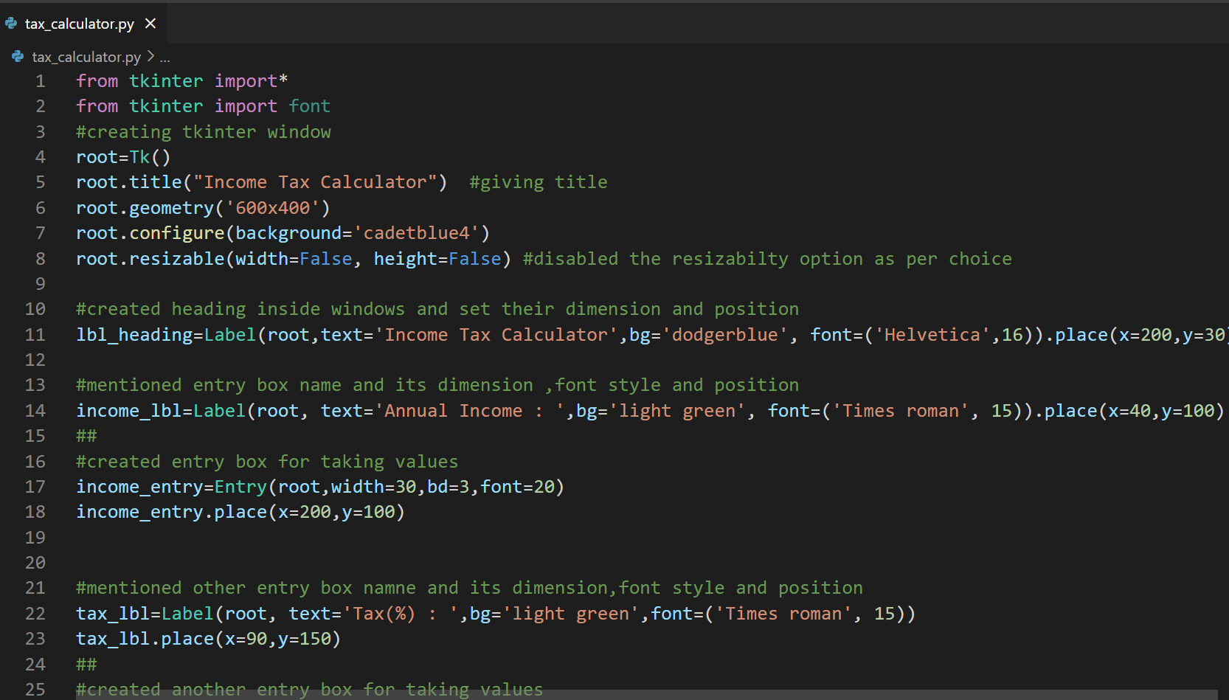

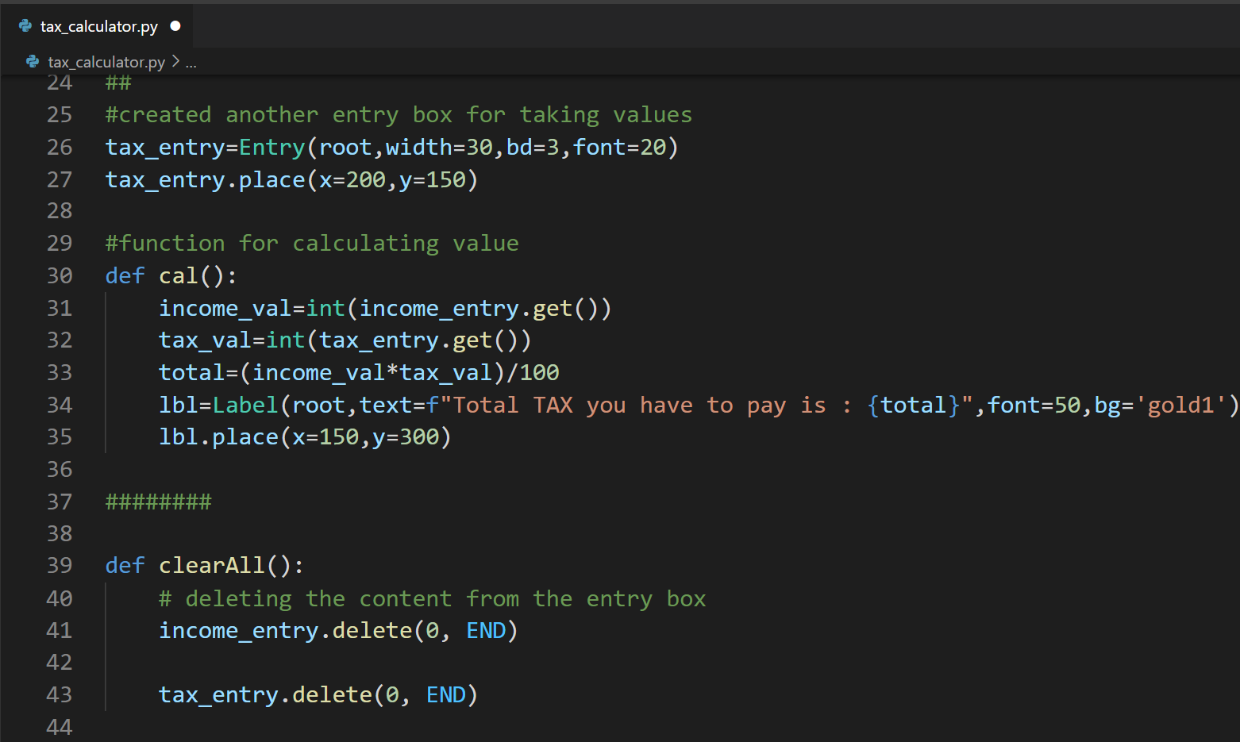

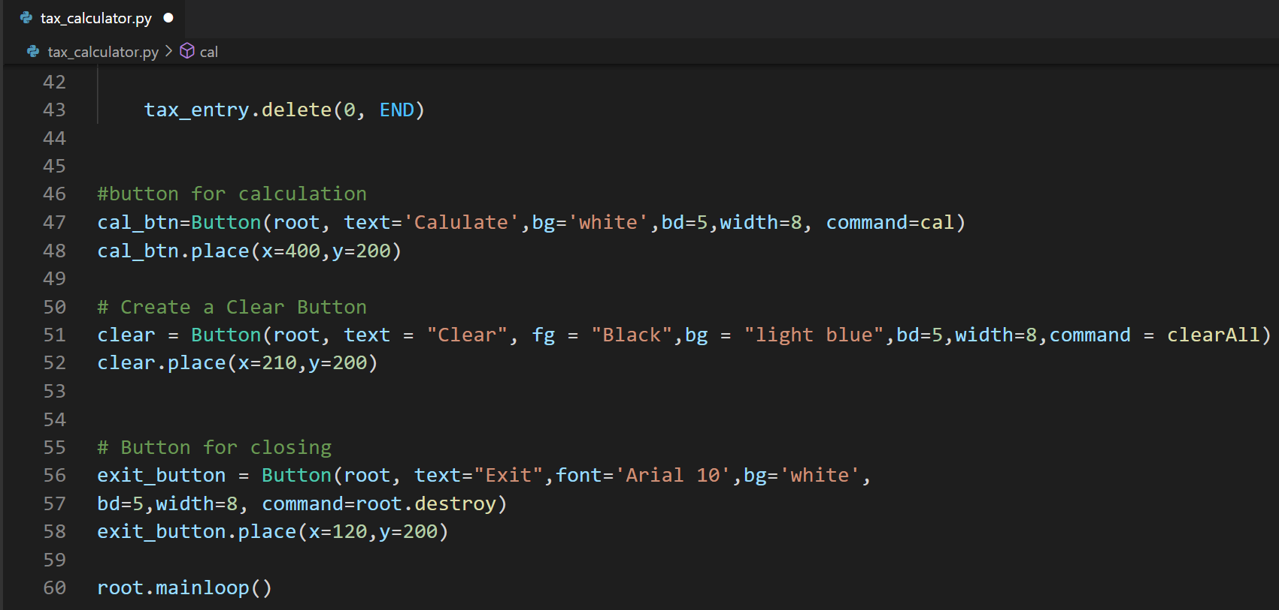

2.Result

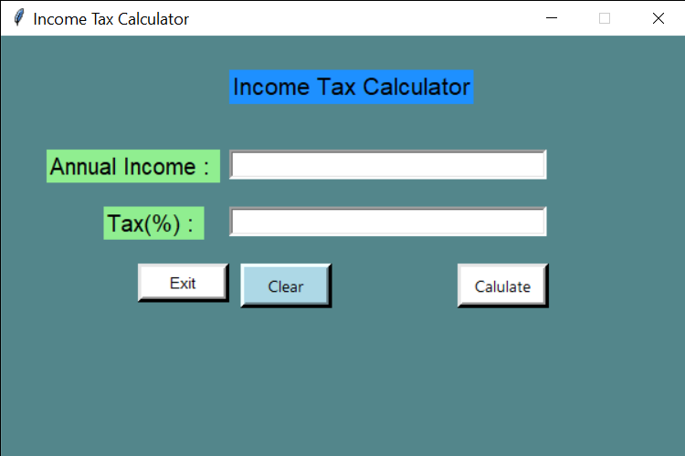

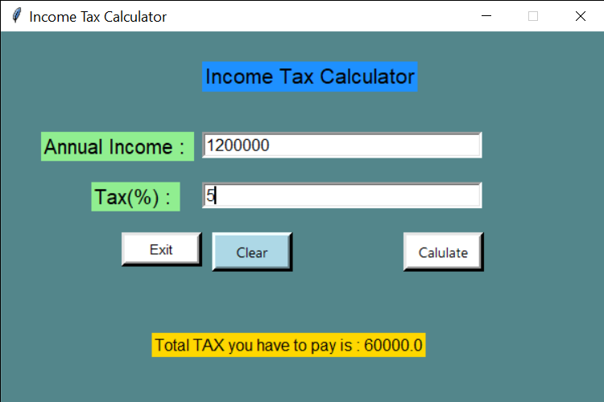

# ***REFRENCES:-***

To conduct this project the following tools have been used :

* <https://youtube.com/playlist?list=PLM7t1QCVTNl8HNgWHcCMnAfrgcRMsjMwu>
* Book : Core Python Programming by Dr. R. Nageswar Rao.